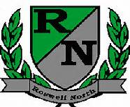
Roswell North Elementary
School Governance Council

Date: January 25, 2016
Time: 4:00 PM
Location:
Large Conference Room, Roswell North Elementary

Agenda

Call to Order
Action Items
Approve December Minutes
Approve January Agenda
Appoint and approve a Budget Chair

Discussion Items
Reports from PTA Board Meeting, Foundation Meeting and Seed Fund
Report from Communication Chair regarding Elections
Report from Sarah Gruber on Grant Champion Meeting
Report from Council members who attended the Strategic Planning meeting
Review input gathered from Goal Setting exercise with stakeholders (Instructional Council, PTA, Foundation)
Set agenda for February Meeting
Discuss Action Items for Next Meeting

Information Items
Members must attend 75% of the meetings and may not miss 3 consecutive meetings

Future Meeting Dates:
Monday February 22nd at 4:00pm
Monday March 14th at 4:00pm
Adjourn meeting

