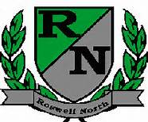
Roswell North Elementary
School Governance Council

Date: November 11, 2015
Time: 4:00 PM
Location:
Large Conference Room, Roswell North Elementary

Agenda

Call to Order
Action Items
Approve October Minutes
Approve November Agenda

Discussion Items
Reports from PTA Board Meeting, Foundation Meeting
Discuss and Review SGC goals – led by Patty Hampel
Review feedback from Seed Fund initial application & begin work on final application
Set agenda for December Meeting
Discuss Action Items for Next Meeting

Information Items
Members must attend 75% of the meetings and may not miss 3 consecutive meetings

Future Meeting Dates:
Monday December 7th at 4:00pm
Monday January 11th at 4:00pm
Monday February 22nd at 4:00pm
Monday March 14th at 4:00pm
Adjourn meeting

