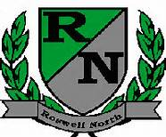
Roswell North Elementary
School Governance Council
Proposed Agenda

Date: September 16, 2015
Time: 4:00 PM
Location:
Large Conference Room, Roswell North Elementary

Call to Order
Action Items
Approve August Minutes
Approve September Agenda

Discussion Items
Reports from PTA Board Meeting, Foundation Meeting
Establish norms
Review goals
Discuss Accountability for Seed Fund
Discuss ideas for Seed Fund
Discuss and Set agenda for October Meeting
Discuss Action Items for Next Meeting

Information Items
Members must attend 75% of the meetings and may not miss 3 consecutive meetings

Future Meeting Dates:
Wednesday October 7th at 4:00pm
Monday November 11th at 4:00pm
Monday December 7th at 4:00pm
Monday January 11th at 4:00pm
Monday February 22nd at 4:00pm
Monday March 14th at 4:00pm
Adjourn meeting

