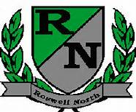
Roswell North Elementary
School Governance Council

Date: August 19, 2013
Time: 4:30 PM
Location: Roswell North ES, large conference room

Agenda
-Call to Order
-Approval of last meetings minutes
-Discussion and vote on replacement of Cari Begin
-Discussion on Survey Results (Ayo Richardson)
-Strategic Plan (Learning Outcomes) Kindra Smith
-Update on Budget and Finance Committee (John Hannah)
Adjourn Meeting
Next Scheduled SGC Meeting Monday September 16th 3:00PM

