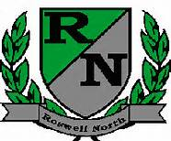
Roswell North Elementary
School Governance Council

Date: December 16, 2013
Time: 3:00 PM
Location: large conference room

Agenda
-Call to Order/Approve agenda
-Action Items: Approve November Minutes
-Discussion: RFF Public Comment
-Discussion: Seed Fund
-Discussion: Uniforms
-Information Items: Communication Update: use Fulton Co. email addresses to communicate
-Information Items: Set Meeting Dates and Time for Remainder of Year: Jan. 27, Feb. 24, March 17, April 21, May 19, June 16
-Adjourn Meeting

