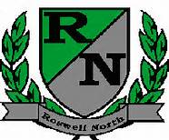
Roswell North Elementary
School Governance Council

Date: May 20, 2013
Time: 3:05-4:05 PM
Location: Roswell North ES, large conference room

Agenda
- Call to Order
- Approval of last meetings minutes
- PBIS Program (Kindra Smith)
- Organization/environmental school scan update (Kindra Smith, Darrell Weaver, Cari Begin)
- Open discussion on technology curriculum integration (Brett Ward)
- Update on Budget and Finance Committee (John Hannah)
- Update on Outreach and Communications Committee (Ayo Richardson)
- Adjourn Meeting

Next Scheduled SGC Meeting Monday June 17th 3:00PM

