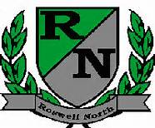
Roswell North Elementary
School Governance Council

Date: November 18, 2013
Time: 3:00 PM
Location: large conference room

Agenda
- Call to Order
- Approval of last meeting minutes
- Vote on chair/co chair positions
- Seed fund request draft
- Communications committee update
- Budge/finance committee update
- Adjourn Meeting
*Next scheduled SGC meeting Monday, December 16th at 3 PM

