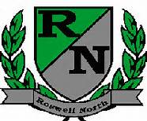
Roswell North Elementary
School Governance Council

Date: October 21, 2013
Time: 3:00 PM
Location: Lynn Coleman’s office (room 16)

Agenda
Call to Order
Approval of last (2) meeting minutes
Cross Council Meeting Update (Seed Fund)-John Hannah
Waiver/Seed fund ideas-Kindra Smith
Communications Committee Update- Ayo Richardson
Budget/Finance Committee Update-John Hannah
Adjourn Meeting

Next Mtg Scheduled-Nov. 18, 2013 at 3 PM

