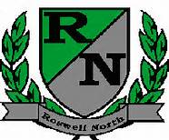
Roswell North Elementary
School Governance Council

Date: September 27, 2013
Time: 3:00 PM
Location: Lynn Coleman’s office

Agenda
Review and vote on strategic plan

