Topic | Facilitator | Duration
- Opening – RNE ‘Share’ | Jay | 5 minutes
Action Items:  - Approve February minutes  - Approve March agenda | Sara | 5 minutes
Team Report Reviews  - PTA, Foundation, Dads Club | All | 5 minutes
SGC Initiative(s) – Updates and Action Items  - Update on elections and increasing voter turnout (voting March 22-28)  - Update on website revisions from communications committee  - Revisit dashboard plan | Amy, David, Patty | 20 minutes
Calendar Review and Update  - Review and update communications schedule | Amy | 5 minutes
Next Steps  - Confirm agenda and action items for next meeting | Brittney | 5 minutes
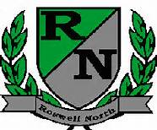
Roswell North Elementary
School Governance Council

Meeting Date: March 2, 2017
Meeting Time: 3:30-5:00 pm
Meeting Location: RNE conference room

Agenda

