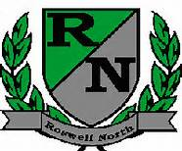
Roswell North Elementary
School Governance Council

Date: April 25, 2016
Time: 4:00 PM
Location:
CST Office, Roswell North Elementary

Agenda

Action Items
Approve March Minutes
Approve April Agenda

Discussion Items
Reports from PTA Board Meeting, Foundation Meeting and Seed Fund
Report from Communication Chair regarding Elections
Report from Council members who attended the Strategic Planning process
Review work from April 13 work session.
Review input gathered from Goal Setting exercise with stakeholders (Instructional Council, PTA, Foundation)
Review Community focus group feedback
Review short term/ long term outcomes for Strategic Planning meeting 3 (Thurs 3/31)
Maureen will have and can review CCRPI data

Information Items
Members must attend 75% of the meetings and may not miss 3 consecutive meetings
Future Meeting Dates:
May 12th at 4:00pm
Set June Meeting

