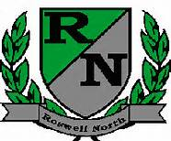
Roswell North Elementary
School Governance Council

Date: May 18, 2016
Time: 4:00 PM
Location:
CST Office, Roswell North Elementary

Agenda

Action Items
Approve April Minutes
Approve May Agenda

Discussion Items
Reports from PTA Board Meeting, Foundation Meeting and Seed Fund – 5 mins
Report about next steps for SGC Certification Update – 5 min
Discuss the plan for sharing Strategic Plan draft with faculty – 5 min
Complete Strategic Plan narrative – 40 min
Discuss agenda for Cross Functional Meeting on June 2 – 10 min
Discuss agenda and action items for June meeting –

Information Items
Members must attend 75% of the meetings and may not miss 3 consecutive meetings
Future Meeting Dates:
May 23thrd at 4:00pm (if needed)
Set June Meeting

Adjourn meeting

