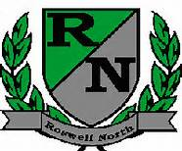
Roswell North Elementary
School Governance Council

Date: May 23, 2016
Time: 4:00 PM
Location:
CST office, Roswell North Elementary

Agenda

Action Items
Approve May 18 Minutes
Approve May 23 Agenda

Discussion Items
Review and Revise Strategic Plan narrative – 40 min
Discuss agenda for Cross Functional Meeting on June 2 – 15 min
Discuss agenda and action items for July meeting

Information Items
Members must attend 75% of the meetings and may not miss 3 consecutive meetings
Future Meeting Dates:
Set July Meeting

Adjourn meeting

