Topic | Facilitator | Duration
- Opening – RNE ‘Share’ | Laureen | 5 minutes
Action Items:  - Approved December minutes  - Approved January agenda  - Report regarding elections; point person | Sara | 5-10 minutes
Team Report Reviews  - PTA, Foundation, Dads Club | All | 5 minutes
SGC Initiative(s) – Updates and Action Items  - Reviewed, discussed, and voted on personalized learning devices  - Updated on Seed Fund feedback  - Discussed possibilities for Bear Time communications  - Updated on Magic Moments plan | Maureen, Patty | 30 minutes
Calendar Review and Update  - Reviewed and updated communications schedule | Amy | 5 minutes
Next Steps  - Confirmed agenda and action items for next meeting | Brittney | 5 minutes
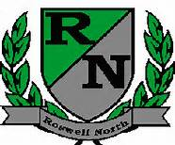
Roswell North Elementary
School Governance Council

Meeting Date: January 12, 2017
Meeting Time: 3:30-4:30 pm
Meeting Location: RNE conference room

Agenda

