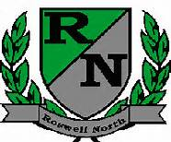
Roswell North Elementary
School Governance Council

Date: November 11, 2015
Time: 4:00 PM
Location:
Large Conference Room, Roswell North Elementary

Summary

Meeting Called to Order
Action Items
Approved October Minutes
Approved November Agenda
Approved Vice Chair position

Discussion Items
Reports from PTA Board Meeting, Foundation Meeting
Discussed and Reviewed SGC goals – led by Patty Hampel
Feedback from Seed Fund initial application was not available – set work session for next week to review
Set agenda for December Meeting
Discussed Action Items for Next Meeting

Information Items
Members must attend 75% of the meetings and may not miss 3 consecutive meetings

Future Meeting Dates:
Monday December 7th at 4:00pm
Monday January 25th at 4:00pm
Monday February 22nd at 4:00pm
Monday March 14th at 4:00pm
Adjourned meeting

