Topic | Facilitator | Duration
- Opening – RNE ‘Share’ | Bethany | 5 minutes
Team Report Reviews  - PTA, Foundation, Dads Club | All | 5 minutes
Action Items:  - Approved October minutes  - Approved November agenda  - Set point people for RFF and Seed Fund | Sara | 5 minutes
SGC Initiative(s) – Updates and Action Items  - Reviewed communications project scope and timeline  - Set 2016-2017 SGC goals and selected point people for initiatives/goals | Amy, Sara | 20-30 minutes
Calendar Review and Update  - Reviewed RFF next steps  - Reviewed Seed Fund next steps | Sara | 5-10 minutes
Next Steps  - Confirmed agenda and action items for next meeting | Brittney | 5 minutes
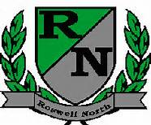
Roswell North Elementary
School Governance Council

Meeting Date: November 3, 2016
Meeting Time: 3:30-5:00 pm
Meeting Location: RNE conference room

Meeting Summary

