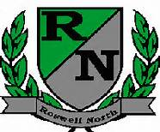
Roswell North Elementary
School Governance Council

Date: December 7, 2015
Time: 3:30 PM
Location:
Large Conference Room, Roswell North Elementary

Summary

Called to Order
Action Items
Approved November Minutes
Approved December Agenda
Approved Seed Fund Application

Discussion Items
Reports from PTA Board Meeting, Foundation Meeting and Seed Fund
Finalized the Seed Fund Final Application
Set agenda for January Meeting
Discussed Action Items for Next Meeting

Information Items
Members must attend 75% of the meetings and may not miss 3 consecutive meetings

Future Meeting Dates:
Monday January 11th at 4:00pm
Monday February 22nd at 4:00pm
Monday March 14th at 4:00pm
Adjourned meeting

