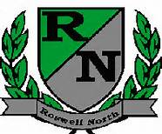
Roswell North Elementary
School Governance Council

Date: February 22, 2016
Time: 4:00 PM
Location:
Large Conference Room, Roswell North Elementary

Agenda

Called to Order
Action Items
Approved January Minutes
Approved February Agenda
Reviewed and approved the 2016-2017 Budget

Discussion Items
Reports from PTA Board Meeting, Foundation Meeting and Seed Fund
Report from Communication Chair regarding Elections
Report from Council members who attended the Strategic Planning process
Reviewed and completed other tasks, as needed, for Strategic Planning process (Lilly and Gruber)
Developed questions for the teacher input meetings (David Keating)
Reviewed part 1 of input gathered from Goal Setting exercise with stakeholders (Instructional Council, PTA, Foundation)
Set agenda for March Meeting
Discussed Action Items for Next Meeting
Set the April and May meeting dates

Information Items
Members must attend 75% of the meetings and may not miss 3 consecutive meetings

Adjourned meeting

