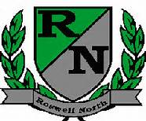
Roswell North Elementary
School Governance Council

Date: March 28, 2016
Time: 3:30 PM
Location:
CST Office, Roswell North Elementary

Agenda

Action Items
Approved February Minutes
Approved March Agenda

Discussion Items
Reports from PTA Board Meeting, Foundation Meeting and Seed Fund
Report from Communication Chair regarding Elections
Report from Council members who attended the Strategic Planning process
- Strategic Planning Focus Group reviewed
- Strategic Planning Data Assessment reviewed
- Internal Environment data
- Student Learning
- Georgia Milestones
- STAR
- External Environment reviewed
- Community Resources, Trends and Perceptions
- American Fact Finder Data
- Set agenda for March Meeting
- Discussed Action Items for Next Meeting

Information Items
Members must attend 75% of the meetings and may not miss 3 consecutive meetings
Future Meeting Dates:
April 25th at 4:00pm
May 12th at 4:00pm

