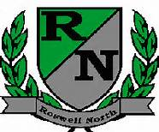
Roswell North Elementary
School Governance Council

Date: May 23, 2016
Time: 4:00 PM
Location:
Media Center, Roswell North Elementary

Action Items
Approved May 18 Minutes
Approved May 23 Agenda

Discussion Items
Reviewed and Revised Strategic Plan narrative – 40 min
Discussed agenda for Cross Functional Meeting on June 2 – 15 min
Discussed agenda and action items for July meeting

Information Items
Members must attend 75% of the meetings and may not miss 3 consecutive meetings
Future Meeting Dates:
Set July Meeting

Adjourned meeting

